*READ THIS FIRST*

*The following introductory section is for the information of persons using the protocol template and guideline and should be deleted from the final version of the protocol. Instructions and examples within the template are in italics and should likewise be deleted. The Appendices to the guideline should also be deleted from the final document.*

*Staff may consult the* [Quality Activity Decision Tool](https://qheps.health.qld.gov.au/__data/assets/pdf_file/0035/2155958/2-01-002-002.pdf) *Work Instruction (2.1.2.2) to determine whether their project meets the criteria for research, or is better categorised as a quality activity (i.e. service evaluation or clinical audit). Protocol templates suitable for clinical audit and service evaluation are available from the Research Support Team (*[DDHHSResearchSupport@health.qld.gov.au](mailto:DDHHSResearchSupport@health.qld.gov.au)*). For assistance categorising projects or completing the protocol, please contact the Research Support Team.*

*The Guideline is designed to assist you to complete the DDH General Research Protocol Template to the standard required for submission to the DDH Human Research Ethics Committee with your Ethics application. Headings in bolded black type should be considered as indicative of the information required, however sub-sections may be deleted where they are not relevant to a particular study.*

*The General Research Protocol is not suitable for clinical trials; please use the* [OHMR Protocol template](https://www.health.qld.gov.au/ohmr/documents/regu/gcp_sop4_a1.doc) *for clinical trials research protocols.*

*Researchers are reminded that research involving humans or their data or samples, may not be commenced without prior review and approval by a Human Research Ethics Committee, and research involving any Darling Downs Health resources must not be commenced without additional approval of the Chief Executive via the Research Governance Office.*

*BEGIN HERE*

**Title of Research Project**

1. **Investigators**

*Name, position, contact information, study role.*

* *Ensure you have discussed involvement with all persons listed as researchers, and that all team members are clear on the role they will undertake.*
* *Position: refers to position in their organisation – DDH or external (e.g. DDH Senior Psychologist, RMO Toowoomba Hospital, Griffith University Biostatistician)*
* *Contact information: Best LONG TERM contact; consider what is least likely to change…a mobile phone; a PO Box; not necessarily a work contact.*
* *Study role: What role will they perform on the study team (i.e. Principal Investigator, Associate Investigator, Project Manager, Site Liaison, Research Assistant).*

1. **Study sites**

* *Study sites are facilities at which the research will be conducted, including worksites. For example; a study being conducted with participants (patients) at Mt Lofty, utilising staff from My Lofty to collect data, which is collated by the Principal investigator at the Toowoomba Hospital and forwarded to a University of Queensland researcher for analysis, will list Mt Lofty, Toowoomba Hospital and The University of Queensland RCS.*
* *“DDH” is not an adequate description of the location of the study. If a study is conducted at numerous facilities within the DDH, all facilities must be listed. If the study occurs at only one facility, the name of that facility must be provided. If the study is conducted across all facilities (e.g. an online survey), this must be stated clearly.*

1. **Introduction & Background**

*Introduce the topic; remember that the HREC members reviewing your research may not be familiar with the research topic or your area of practice; avoid jargon and technical terms when possible.*

* 1. **Rationale and purpose of the study**

*Why is this research significant– to patients, community, the HHS, nationally, economically, socially…*

* 1. **Literature review**
* *Conduct and write a literature review to identify existing knowledge on the subject*
* *What has already been done in this area?*
* *How does your study fit in – what gap does it fill in the current knowledge?*
* *Contact the DDH Librarians for assistance with literature searches and formatting a literature review. They are expert in this area and know how to locate relevant articles.*
* *Ensure all citations are included in your reference list.*

*It is recommended that you use referencing software (e.g. EndNote) from this early stage to organise and track your literature. If in doubt, see the Librarians for assistance.*

* 1. **The gap in current knowledge***:*

*Having explained what is known about the subject from the literature, now explain how your research will address some aspect of what is not known about the subject.*

1. **Aims & Objectives** 
   1. **Aim/s:**

*What is the broad aim of the study? e.g. “The aim of the study is to determine whether model A or model B diabetes self-management intervention is more effective for adults with type 2 diabetes and severe mental illness, living in the community.”*

* 1. **Objectives:**

*The study objectives are separate statements of quantifiable attainments which will support your main aim. Secondary objectives may not be directly related to the research question, but are points which will be investigated in the course of the study.*

* *e.g. Primary objective: To compare the outcomes of two diabetes self-management interventions*
* *Secondary objectives: 1) To determine the prevalence of comorbid type 2 diabetes and severe mental illness within the catchment area; 2) to determine which self-management programs for type 2 diabetes, specific to persons with severe mental illness, are currently being implemented within the community, and what supports are associated with each program.*
  1. **Research Question:**

*Do you have a research question? Research questions need to clearly delineate the population and the investigation. Where relevant, it should also state the intervention, the comparison and the outcome of interest.*

* *Check the resources on developing a research question on the DDH Research page.*

*Example: “In a regional centre, what is the rate of uptake of specialist orthodontic services by the Indigenous community, compared to the non-Indigenous community?” (A research question should be written as a question.)*

* 1. **Hypothesis:**

*An hypothesis describes in concrete (rather than theoretical) terms what you expect will happen in your study. A single study may have one or many hypotheses, but not all studies will have an hypothesis. Sometimes a study is designed to be exploratory, where perhaps the purpose of the study is to explore some area more thoroughly without a specific theory of what will be found.*

* *Do you have a theory on what the outcome will be? e.g. “In a regional centre, the rate of uptake of specialist orthodontic services by the Indigenous community will be lower than that of the non-Indigenous community.”*

1. **Method:**

*In this section you will be required to provide details of how you investigate your research question. Think about -*

* *How are you going to conduct your research: e.g. data linkage; a retrospective chart audit; a prospective cross-sectional study; a double blind randomised experiment; qualitative research? It may be a combination of methods; this is fine and should be explained.*
* *What is the population you will be recruiting from? E.g. all patients/all males/males over 50; with a particular diagnosis/undergoing a certain procedure; in all Qld hospitals/all public hospitals/Toowoomba Hospital/your clinic; in the past 10 years/12 months/the next 6 months …*
* *What specifically is the study looking at? E.g. …who were admitted to the Emergency Department for head trauma/underwent a medication review on discharge form the Toowoomba Hospital …*
* *What will you manipulate or vary in each patient/participant (e.g. treatment modes/times), and how will you vary it OR what aspect of each patient’s experience will you examine?*
* *What will you measure or compare to determine the outcome?* 
  1. **Study design**

*State briefly the design of the study e.g. “this is a prospective cohort study, with data collection points at baseline and 3 months post-treatment completion”.*

* 1. **Participants**
     1. **Sample size***: HRECs require an indication of sample size, and statisticians may use this to determine whether you have a big enough sample size to produce meaningful results (depending on the type of research you are doing). You may need to estimate participant numbers based on national prevalence rates or presentations to the department or clinic. For further assistance determining the required sample size for your proposed study, contact the Research Support Team.*
     2. **Inclusion/Exclusion:**
* *What are the inclusion criteria for participants? Equally important, who will be excluded, and why? You must provide a rationale for the exclusion of any particular group of people.*
* *How will recruits be screened: clinical judgement/a questionnaire/information from charts; when and by whom?*
* *See the Appendices for examples*
  + 1. **Participant Information:**

*How are you providing information to potential participants? There are clear guidelines around the provision of information to participants; what can and cannot be said, and how information may be communicated. Mistakes in the construction of the Participant Information documents commonly delay ethics approval. It is therefore recommended that you utilise an approved standardised template for Participant Information and Consent forms created for this purpose. See the links on the DDH Research webpage. You are encouraged to seek assistance from the Research Support Team when developing your participant information document/s.*

* + 1. **Interventions and/or Participant Activities**
* *Clearly state how the research intervention differs from, or is an adjunct to, current standard practice.*
* *List all activities the participant will be required to undertake, whether active or passive.*
* *In some cases, data from standard assessments may be utilised for research; this must be clearly explained (both in the protocol and in the participant information documents).*
* *In the case of clinical research where research activities are undertaken during the course of clinical care, explain how this will occur and whether it will require an extra time commitment by participants.*
* *If data are being used for research which were originally collected for another purpose (e.g. patient medical files or corporate data collections), provide details of how participants will be made aware of this.* 
  + 1. **Recruitment and Consenting:**
* *In studies involving a substantial time commitment by participants, or the imposition of invasive procedures, it may be necessary to allow potential participants time to give due consideration to the requirements of participation. Sufficient time should be allowed between provision of information about the study and the consent interview for this to occur. For example; participant information may be provided at a first appointment and the decision about participation (and consent where applicable) provided by the patient at a follow-up appointment.*
* *Clearly describe how patients will be recruited; who will give them the Participant Information and when; who will answer participants’ questions and who will conduct the consent interview, and when. If this is complex, consider a flowchart to illustrate the procedure. See the Appendices for examples.*
* *You may request a waiver of consent under certain condition; these are contained in the National Statement. If you think you may require a waiver, contact the DDH HREC Coordinator on 4616 6696 or DDHHS-RESEARCH@health.qld.gov.au*
* *Accessing patient contact details requires ethical approval prior to using the medical records/and or systems for the purpose of research. There are circumstances under the Hospital and Health Services Board Act 2011 Section 150 where it is possible to access confidential information if you are a designated person. For all other non-designated personnel, the Public Health Act (PHA) 2005 application process still applies. A designated person is described under Section 139A of the HHB Act 2011. Please contact the HREC coordinator or the Research Support Team for further information on accessing confidential information if you require further clarification.*
  1. **Data collection** *– procedures and tools*

*Your literature review will help to identify methods used in similar research projects and how the variables can be operationalised. It will also identify any standardised tools which have been used by other researchers in this area (e.g. questionnaires).*

* ***What*** *data will you collect? e.g. Demographics/ results of physical assessments/ results of pathology analyses/ mental health measures etc.*
  + *Clearly define which assessments are study specific and which are routine clinical care (even if you are collecting the data from the routine tests for your study). Consider using a table of study assessments to illustrate study procedures, timeframes and schedules. See the Appendices for examples.*
  + *To find out what data is held by DDH and accessible to researchers, contact the Activity & Costing Evaluation Service: DD_Activity&Costing@health.qld.gov.au or phone 4699 8014.*
* *How* ***frequently*** *will it be collected? e.g. Once only/pre-post intervention/at monthly intervals/annually; daily for one week etc.* 
  + *Consider a table to illustrate this if there are multiple data collection points and assessments. See the Appendices for examples.*
* ***How*** *will it be collected? e.g. Chart audit/ diagnostics/ questionnaires/ interviews/online survey/ by phone/ mail/ email.* 
  + 1. **Tools:**
  + *List all measurement tools.*
    - *For assistance locating standardised tools, see the Research webpage or contact the DDH Librarian.*
    - *If you intend to create your own tools (e.g. questionnaires) it is advisable to consult with an experienced researcher who can provide input into the design and content to ensure information collected addresses the research question. All original tools, or amendments to standardised tools, must be submitted to the HREC with the application.*
  + *If you are conducting a chart audit, you will need to create a chart audit form to standardise data collection. It is advisable to consult with an experienced researcher who can provide input into the content to ensure information collected addresses the research question.*
  + *All original chart audit forms, or amendments to standardised forms, must be submitted to the HREC with your application.*
* ***Who*** *will be collecting it? Do you have staff available to collect the data or will you collect them yourself?*
* *If it is collected on DDH time it will have to be approved as DDH in-kind research support. Discuss this with managers before submitting your application.*
* *Consider funding for back fill or a Research Assistant if data collection is going to necessitate a substantial amount of time away from core business.*
* ***ACCESSING AND USING PATIENT INFORMATION****:*

*You are prohibited by law from using data in Queensland Health patient medical records for research purposes without ethics approval. The information contained in medical records is only to be used for the purpose for which it was collected i.e. clinical care. Written permission of the individual patient/s or a waiver of consent will be required for you to use this data. Your ethics approval letter will outline the consent process required for you to access the data i.e. Public Health Act (PHA) approval, HHS Board Act implications or waiver of consent. Further information on the consent process can be obtained at the Health and Medical Research Office, the HREC coordinator or the Research Support Team.*

* 1. **Outcome measures** *– verified / standardised / reliable instruments / tests for measuring outcomes*
     1. **Primary Outcome***: What is the most important outcome you will measure to answer your research question and how will it be measured? e.g. Changes in blood glucose levels/re-admission rates/patient satisfaction scores/length of stay/etc. The primary outcome directly relates to the research question and is used to calculate study sample size and power. Primary outcome measures may be measured in various ways such as: binary (e.g. caesarean/no caesarean, blood loss ≥500mL/blood loss <500mL); continuous (e.g. weight - kg, blood loss - mL); ordinal (e.g. pain - mild, moderate, severe); time to event (e.g. survival), and counts (e.g. number of infections, number of events occurring).*

* + 1. **Secondary outcomes***: Secondary outcomes are of less interest, and do not necessarily address the main research question.*
  1. **Data Analysis** *- techniques for analysing numbers, text and or images*
* *What analysis will be performed – be specific. For Quantitative data, what statistical analyses will be used? If you are not sure, you may consult with the Research Support Team.*
* *Will you need to use a statistician from outside DDH?*
* *Will the analysis require special software? Is this available or will you have to purchase a licence?*
* *Statistical techniques generally require a specific type of data (e.g. continuous or categorical) so the statistical analysis required to answer your research question(s) needs to be decided early, and the design of questionnaires and other data collection tools should reflect these decisions.*

1. **Data management plan**

*The purpose of this section is to assist you in detailing how your data will be managed during the life of your project and beyond. Please complete all sections of the table.*

|  |  |
| --- | --- |
| **6.1. Data owners and stakeholders** | ***Provide details of who will own the data which is generated by the research.***  ***If the project is led purely by a* *Queensland Health (QH) employee, QH will own the data. If the project is in collaboration with another institution, ownership of the data will be negotiated and led by the contractual agreement that should be put into place.***  ***Copyright developed by employees of Queensland Health in the course of their employment is owned by the State of Queensland (Queensland Health). As it is a government copyright, it lasts for 50 years from the year of first publication after which time it becomes public domain.***  ***For further information please go the*** [*Queensland Health Intellectual Property*](https://www.health.qld.gov.au/hiiro/html/rcpu/intel_prop) ***page.*** |
| **6.2. Storage during the study** | ***Provide details of where your data will be stored during the study.***  ***Digital documents:*** *For researchers with digital documents there is a folder set aside for research on the DDH secure network drive Data 7 (W:). The Senior Librarian is the gatekeeper for this folder. Sub-folders for each research project are created by the Librarian and access provided to listed investigators.*  ***Please contact the Library on (07) 4616 6264 or email*** [*DDHHS-Library@health.qld.gov.au*](mailto:DDHHS-Library@health.qld.gov.au)  ***Hard copy documents****: For researchers with hardcopy documents there is a filing cabinet set aside for research in the DDH Library. The Library is located on the upper level of Cossart House, Toowoomba Hospital. It is also acceptable to store hard copy documents within a locked filing cabinet in a locked office of the DDH facilities for the duration of the study. Documents can then be transferred to the secure archive in the DDH Library for long term storage at the conclusion of the study. Contact the Librarians to utilise this service.*  *We encourage every researcher to store their data on QH servers, as this provides a secure storage location with regular automatic backups.*  ***Off site:*** *If research documents are being stored off site (e.g. at University facilities) then details of method, location and security measures must be provided. Seek the advice of the external collaborators who are storing the data for their organisation’s policy and procedure.*  ***Personal PC or laptop****: If you are storing your data on a personal computer, you will need to indicate this and what measures you have undertaken to safeguard the security of the information.* |
| **6.3. Access, confidentiality and security** | ***Explain what format your data will be stored in (i.e. identifiable, re-identifiable, non-identifiable) and provide a rationale for the chosen format. If you intend to render data re-identifiable or non-identifiable, explain how this will be achieved. Note that inclusion of UR numbers mean data are identifiable.***  ***Provide details of who will have access to your data during the study. Include details of how you will ensure access is limited to only those who are approved to access the data, and how you will protect it from unauthorised access (either intentional or accidental). This might be via password protection or encryption.***  ***Off site****: If research documents are being stored off site (e.g. at University facilities) then details must be provided of how unauthorised access will be prevented. Seek the advice of the external collaborators who are storing the data for their organisation’s policy and procedure.*  ***Personal PC or laptop:*** *Provide details of how you will ensure the data on your personal computer is not accessible to anyone other than the researchers.* |
| **6.4. Data sharing and data publishing *(not publication of research findings)*** | ***Provide details of processes for sharing of data (if any).***  ***Sharing of data within your team requires safety measures to be in place. For example: encryption, password protected, through QH emails etc. Will data be shared with your University supervisor or collaborators – if so, will this be de-identified?*** *Justification for movement of data should be made and method of transfer included. The following options are available within the Queensland Health system:*  ***STS (Secure Transfer System)*** *is intended for ongoing routine transfers between internal and external care providers and is NOT RECOMMENDED for research data movement.*  ***SFT (Secure File Transfer)*** *is a system which allows you to email someone with a link to a file, similar to Dropbox. The recipient can then log into the system and download the file. Suitable for research and confidential information transfers to EXTERNAL sites*   * *This is a QH secured, ratified and managed system* * *The service is provided by Kiteworks and incurs an annual fee for each email account (i.e. internal and external users), however a group account can be set up so multiple QH users may use the same account* * *It is available from eHealth* <http://qheps.health.qld.gov.au/sts/html/secure-file-transfer.htm>   ***Microsoft Lync*** *meeting and messaging platform allows secure instant transfer of large data files (too big for email) between INTERNAL QH EMAIL ACCOUNTS (including between HHSs)*   * *Available free to all QH staff* * *Suitable for large internal file transfers e.g. transferring a large data dump from a clinical information system to QH Statistics Unit for linking to other QH enterprise data, etc.*   *See instructions in the Appendices*  ***Will raw data be shared/published after the project is complete? i.e. along with a manuscript submission. Please note that you may not know this information at the beginning of your project, however it will be required to be included in your final report back to the HREC.***  ***NOTE: It is inappropriate to share data outside of your research team.***  *See* [*ANDS Publishing and sharing sensitive data Guideline*](https://www.ands.org.au/__data/assets/pdf_file/0010/489187/Sensitive-Data-Guide-2018.pdf)  ***A note on version control:***  ***Version control is required to ensure the authenticity of research data. While you are not required to provide details of version control procedures, it is recommended that you hold discussions with your research team early on and agree to a consistent process to ensure all team members are using the most current version of the dataset.*** |
| **6.5. Long-term storage, retention and destruction** | ***Provide details of where and for how long your data will be stored after completion of the study. Include details of when and how data will be destroyed – both electronic and hard copy files.***  ***DHHS Secure document storage:* *DDHHS is able to provide short and medium term data storage through the secure research data storage facility described above.*** *The Library will maintain a register of when documents are deposited into the secure locations, and who is responsible for them. The library will use the register to create alerts for when documents need to be reviewed for destruction. Hard copy documents and electronic files will be destroyed according to DDH confidential document destruction protocols. Contact the Librarians to arrange storage within the DDHHS data storage facility.*  ***Note*** *that current DDHHS Library mediated storage is NOT a data repository: it is not findable via external searches, it is not indexed in any forum, and is not curated (i.e. data may deteriorate or become unreadable due to changes in software).*  ***The destruction of data must be irreversible with no chance of recovery later.***  ***If you think that your data may be a candidate for long-term or permanent retention, you should be aware that decisions made at an early stage of the research project can limit your later ability to retain data in a usable form. For example:***   * ***Human ethics requirements and the nature of the consents you seek from participants will determine whether and in what ways data can be re-used for future projects.*** * ***Technology-based decisions relating to storage of data might impact on the length of time that data can be easily retrieved and used.*** * ***If good documentation about the data has not been kept throughout the life of the data, it may be difficult to find the data and make sense of it at a later date, particularly if those originally responsible for the data are no longer at Darling Downs Health.***   ***In general, the minimum recommended period for retention of research data is 5 years from the date of publication. However, in any particular case, the period for which data should be retained should be determined by the specific type of research. For example:***   * ***For short-term research projects that are for assessment purposes only, such as research project completed by students, retaining research data for 12 months after the completion of the project may be sufficient*** * ***For most clinical trials, retaining research data for 15 years or more may be necessary*** * ***For areas such as gene therapy, research data must be retained permanently (e.g. patient records)*** * ***If the work has community or heritage value, research data should be kept permanently at this stage, preferably within a national collection.***   ***You should provide a justification for your nominated retention period.***  [*NHMRC Australian Code for the Responsible Conduct of Research*](https://www.nhmrc.gov.au/about-us/publications/australian-code-responsible-conduct-research-2007#block-views-block-file-attachments-content-block-1) ***Section 2.1***  ***NOTE: If you elect to use the Library, your data will be destroyed according to the***  ***above guidelines.***  ***Off site****: If research documents are being stored off site (e.g. at University facilities) then details must be provided as to where and for how long the data are being stored, and when the documents will be destroyed. Seek the advice of the external collaborators who are storing the data for their organisation’s policy and procedure.*  ***Data stored on a private PC or laptop:*** *Files must be scrambled or overwritten. Deletion does not permanently remove files. If unsure, seek the advice of an IT professional.* |

1. **Ethical and Safety Considerations**
   1. **Research related risks:**

*Some research procedures have the potential to cause harm; either by the nature of the procedure, or due to innate vulnerabilities of the participant group or individual, or due to the topic of the research. Harms may be physical, psychological, social or financial and may accrue to either participants or researchers. These potential harms must be identified at the development stage and procedures put in place to manage them should they occur. Potential harms and subsequent management plans must be included in the protocol. For example; if the researcher is planning to discuss their experience of chronic pain with participants, it is possible that participants may become upset. What plans does the researcher have to manage this?*

*The greater the harm, or potential for harm, the greater must be the potential benefit from the research. The HREC will be more rigorous in its assessment of scientific merit where there is the potential for significant harm. The HREC will also consider issues of equity: will the potential benefits be experienced by the participants or persons similar to the participants; or will the burden of research fall on a different group to those who may benefit.*

* 1. **Duty of Care:**

*During the conduct of the research it is possible that a negative event may coincidentally be identified in or by a participant. If the event is unrelated to the research, it should be handled according to standard clinical referral pathways. For example; while administering a questionnaire on patient satisfaction with the podiatry service, a patient reveals she often forgets which medications to take each day. Following standard clinical referral pathways, the researcher should refer this participant to the pharmacy team for a medication review. You may address this point in your protocol and application with the following sentence: “Coincidental health concerns identified in the course of the research, that do not relate to the research, its procedures or goals, will be managed through standard referral pathways.”*

*Where a clinically significant result is uncovered during the course of research, this must be communicated to the participant. This may be through the participant’s treating health professional, with the participant’s consent. It is the researchers’ responsibility to ensure that the participant understands the clinical significance of such a result, and to provide a referral pathway. If clinically significant outcomes are expected to occur as a direct result of the research, information about communicating such results, and the likely significance of the results, must be communicated to the participant in the Participant Information documents.*

* 1. **Participants in non-intervention arms*:***

*In studies where participants have been divided into intervention and non – intervention arms (e.g. treatment as usual), it may be unethical to withhold treatment from the non-intervention group if the treatment proves to be successful. For this reason, many control groups are taken from a wait list for the intervention. The intervention can then be provided after completion of data collection for the research. Alternatively, with clever designing, this group’s data may be included both pre-intervention (as control data) and post-intervention (as study group data). If you do not intend to offer treatment to the non-intervention group, provide a rationale for this decision.*

1. **Dissemination of results**

*How are you going to report the results of your research and to whom?*

* 1. *Dissemination to the Health Care community: Clinical as well as peer reviewed publication, poster presentation, etc.*
  2. *Feedback to participants: Will you be providing feedback to the participants? At what level: individual or a summary of findings at the conclusion of the study? If you are not providing any feedback you will need to provide an explanation of why not. (This is acceptable in some circumstances, but must be justified.)*

1. **Translation to practice:** *You are required to outline your plan to translate your research into practice. Consider the outcomes of your research; how will they potentially impact on clinical practice? If in doubt, you may consult the Research Fellow.*
2. **Duration of the project:**

*Consider the time required for all research related activities– take into account the time you have available to commit to research and your clinical obligations, planned leave, public holidays, family obligations, the process of ethical review, including Site Specific Assessment/s and PHA, and the time needed to recruit your participants. It is usual to put this information into a Gantt table for easy readability. See example in the Appendices.*

1. **References:** *List all references cited in the Protocol here – this will predominantly be from the literature review.*
2. **Appendices***: List all your appendices here but include them with your ethics application as separate documents. This will include any and all study documents e.g. Data collection tool (if original or modified), survey/questionnaire (if original or modified), Participant Information and Consent forms, Withdrawal of Consent forms, invitation letter, flyer, advertisement, letters of support, as well as investigators CV’s.*

*PROTOCOL ENDS HERE*

*Please delete the following appendices prior to submitting your protocol*

***Guidelines Appendices***

*(Delete from final version)*

***Appendix A: Inclusion/Exclusion criteria (Section 5.2.2)***

***Appendix B: Recruitment and consent flowcharts (Section 5.2.5)***

***Appendix C: Study assessments timeframes and schedules (Section 5.3)***

***Appendix D: Sending a file via Lync (Section 6.3.3)***

***Appendix E: Timeframes (Section 10) Appendix A: Inclusion/Exclusion criteria (Section 5.2.2)***

*Example 1: Inclusion/Exclusion Criteria for a medical study, with probable co-morbidities.*

***Inclusion Criteria:***

1. *Diagnosis of multiple myeloma*
2. *Age more than 18 years old and less than 85 years old*
3. *Currently undergoing treatment with recognised glucocorticoid-based chemotherapy regimens.*

***Exclusion Criteria:***

1. *Recognised diagnosis of primary adrenal insufficiency,*
2. *Diagnosed Cushing’s disease*
3. *Use of oestrogen therapy, the oral contraceptive pill or hormone replacement therapy. \**
4. *Diagnosed nephrotic syndrome \**
5. *Untreated hypothyroidism, which will be identified through pathology results within the last 12 months or if patients are known to have untreated hypothyroidism \**
6. *Pregnant women\**
7. *Participants unable to provide informed consent*

*\* Factors known to affect serum cortisol results.*

*Example 2: Inclusion/Exclusion Criteria for an Allied Health study.*

*Inclusion criteria*

* *Patients admitted to the program between 18/04/2015 – 18/07/2015*
* *Patients on the rehabilitation program for over two weeks.*
* *Clinicians that have worked on the rehabilitation ward for longer than one month.*

*Exclusion criteria*

* *Patients on the rehabilitation program prior to 18/04/2015*
* *Patients on the rehabilitation program for under 2 weeks.*
* *Patients seen in the acute stroke unit (ASU) by the Advanced Allied Health Practitioner.*

*Example 3: Simple Inclusion Criteria.*

*Eligible mothers will be those who give birth to a live child in a participating hospital, have sufficient grasp of the English language to complete the questionnaire, are over 18 years of age, and can be contacted by telephone for six-month follow up.*

***Appendix B: Recruitment and consent flowcharts (Section 5.2.5)***

*Example 1: Study procedures flowchart for a RCT (not pharmacological), with screening procedures*

|  |  |  |
| --- | --- | --- |
| WEEK 1 Recruitment | NOT INTERESTED  Contact by Admin staff  INTERESTED:  Admin makes appointment with Psychologist for 7-10 days and posts out PICF/SCREENING | No further contact |
| WEEK 2 Screening visit | Appointment 2 with Psychologist  Consent interview for RCT  INELLIGIBLE  or  NOT INTERESTED  DOES NOT CONSENT  ELIGIBLE: makes appointment with psychologist for Consent interview  Psych contacts Pt to advise eligibility  CONSENTS to SCREENING:  Psychologist administers SCREENING assessments  Supplies PICF/RCT for Pt to take home  Appointment 1 with Psychologist  Consent interview for SCREENING |  |
| WEEK 3 RCT randomisation | DOES NOT CONSENT  CONSENTS to RCT:  RANDOMISATION. Pt advised of Group membership |  |
| TREATMENT & FOLLOW UP | GROUP 1: intervention for 6 months  GROUP 2: Treatment As Usual /6 months  Participant may withdraw at any time  Follow-up 2: 6 months post treatment  Follow-up 1: Completion of treatment  Baseline Assessment Measures: Pre-treatment |  |

*Example 2: Study procedures flowchart for an evaluation of standard clinical practice.*

Patient not interested in study:

Patient continues with treatment: no further involvement in study

**Initial appointment with consultant**

1. Positive Dx: Agrees to standard treatment

2. Discussion about study

Patient fails to meet inclusion/exclusion criteria:

Patient continues with treatment, no further involvement in study

Patient meets inclusion/exclusion criteria:

Patient gives written informed consent prior to treatment

Patient willing to participate in study:

Inclusion/exclusion criteria applied

Patient unwilling to participate:

Patient continues with treatment; no further involvement in study

**Follow-up appointment for treatment**

Patient expresses interest in study:

PICF provided to patient

***Appendix C: Study assessments timeframes and schedules (Section 5.3)***

*Example 1: All assessments performed at all visits – across three participant groups*

*Schedule of assessments at Baseline, 2 and 4 months.*

|  |  |  |  |
| --- | --- | --- | --- |
|  | Achilles Tendinopathy | Patellar Tendinopathy | Lateral Epicondylosis |
| VAS | x | x | x |
| PGIC | x | x | x |
| VISA-A | x |  |  |
| VISA-P |  | x |  |
| PRTEE |  |  | x |
| Tegner Activity Scale | x | x |  |
| Quadriceps Dynamometry |  | x |  |
| Calf Dynamometry | x |  |  |
| Grip Strength |  |  | x |

*Visual Analogue Scale to assess pain scores*

*Tegner Activity Scale to assess functional impairment prior to injury and post treatment for lower limb tendinopathies*

*Victorian Institute of Sports Assessment Questionnaires for Achilles (VISA-A) and Patella (VISA-P) to assess severity of injury to the affected site*

*PRTEE to assess severity of injury to the affected site in participants with Lateral Epicondylar tendinopathy*

*Patient Global Impression of Change (PGIC) scale*

*Grip Strength, Quadriceps-Patellar Dynamometry and Calf –Achilles Strength assessment as appropriate*

*Example 2: Includes screening for eligibility*

|  |  |  |  |  |  |  |
| --- | --- | --- | --- | --- | --- | --- |
|  | BCAT-SF | SCID-5 | BDI-II | BAI | ASSIST | QoL |
| Screening | X | X |  |  |  |  |
| Baseline |  |  | X | X | X | X |
| 6 months from Baseline |  |  | X | X | X | X |
| 12 months from Baseline |  |  | X | X | X | X |

*BCAT-SF = The Brief Cognitive Assessment Tool Short Form*

*SCID-5 = Structured Clinical Interview for DSM-5*

*BDI-II = BECK Depression Inventory-II*

*BAI = Beck Anxiety Inventory*

*ASSIST = Alcohol, Smoking and Substance Involvement Screening Test*

*QoL = Quality of Life*

*Example 3: Differentiates between Routine assessments and Study specific assessments*

|  |  |  |  |  |  |  |
| --- | --- | --- | --- | --- | --- | --- |
| **Procedure** | Weeks | | | Months | | |
|  | 0 | 1 | 2 | 3 | 6 | 12 |
| RA: Screening | ✓ |  |  |  |  |  |
| SA: Inclusion/Exclusion | ✓ |  |  |  |  |  |
| SA: Informed Consent | ✓ |  |  |  |  |  |
| RA: Demographic data | ✓ |  |  |  |  |  |
| SA: Comorbidity questionnaires | ✓ |  |  |  |  |  |
| RA: Clinical history | ✓ |  |  |  |  |  |
| RA: Current medications | ✓ |  |  |  |  |  |
| RA: Physical examinations | ✓ |  |  |  |  |  |
| RA: Blood Investigations | ✓ | ✓ | ✓ | ✓ | ✓ | ✓ |
| RA: Skeletal Survey | ✓ |  |  |  |  |  |
| RA: Urine | ✓ |  |  |  |  |  |
| RA: Bone Marrow Studies |  | ✓ |  |  |  |  |
| SA: Nerve Conduction/EMG^ |  | ✓ |  |  | ✓ |  |
| SA: Lumbar Puncture/CSF* |  |  | ✓ |  |  |  |
| SA: Pain Questionnaires | ✓ | ✓ | ✓ | ✓ | ✓ | ✓ |

*RA = routine assessment; SA = study assessment*

*^EMG: Electromyography;*

*\*if abnormal nerve conduction study results*

***Appendix D: Sending a file via Lync (Section 6.3.3)***

* ***Lync*** *provides a secure method for internal transfer of files up to 4 GB. This size files should be more than adequate for the majority of staff needs.*
* *Consider password protecting the excel file for confidential data.*
* *It is also recommended you compress large files to a zipped file.*

***1. Compressing the file***

*1.1. Right-click on the file in the explorer window, click Send to, then Compressed (zipped) folder*

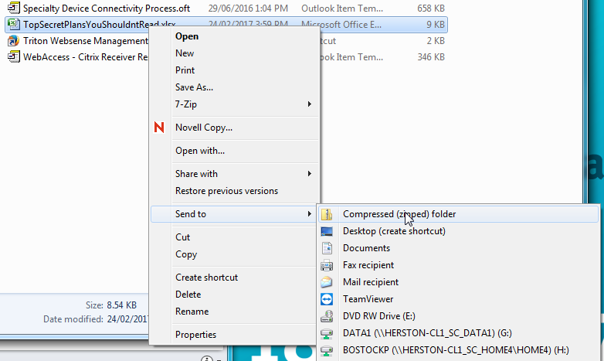

*1.2. A Zipped file will be created*

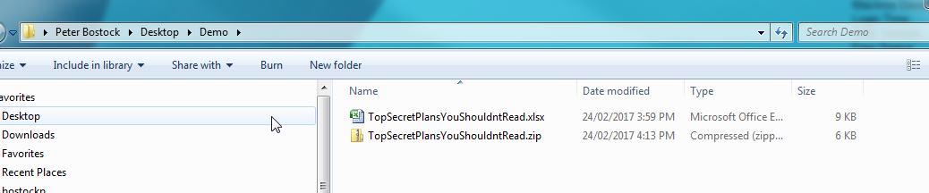

***2. Transfer by Lync***

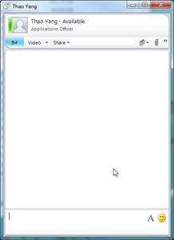

*The steps to transferring by Lync are straightforward.*

*2.1 Find the person you wish to transfer the file to and*

*send them a Lync message.*

*2.2 When they respond, advise them you are transferring*

*the file.*

*2.3 Click the paperclip icon*

*2.4 Find the file you wish to transfer and “open” to attach to the Lync message.*

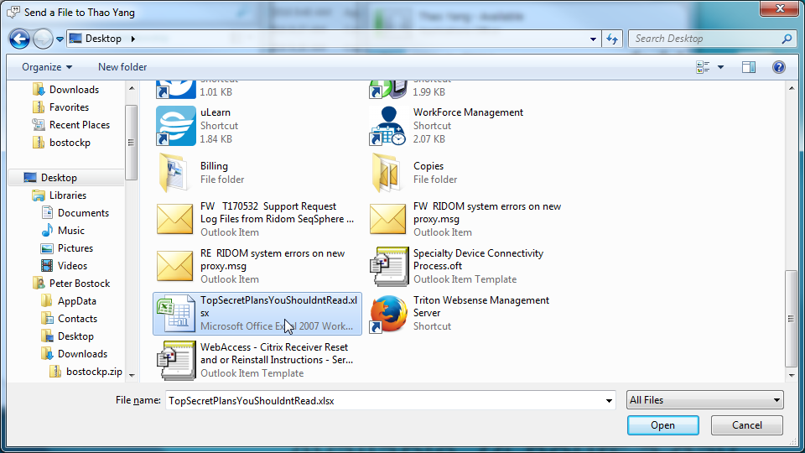

*2.5 The receiver has to accept the file, and it will transfer over the network.*

*Depending on the size, it may take a while.*

*2.6 The receiver will get a message similar to the one below:*

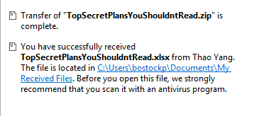

*The imported file will be located in their Documents directory under Received Files.*

*[Thanks to Peter Bostock, Senior Application Specialist, Digital Application Services – Business Applications, eHealth Queensland,* ***Department of Health*** *for information on transfer of confidential information for Section 6.3 and the above instructions.]*

***Appendix E: Timeframes (Section 10)***

*Timeframes – a Gantt chart*

|  |  |  |  |  |  |  |  |
| --- | --- | --- | --- | --- | --- | --- | --- |
| *Activity* | *Mar/Apr 2017* | *May/Jun 2017* | *Jul/Aug 2017* | *Sep/Oct 2017* | *Nov/Dec 2017* | *Jan/Feb 2018* | *Mar/Apr 2018* |
| *Obtain ethics approvals* |  |  |  |  |  |  |  |
| *Recruit* |  |  |  |  |  |  |  |
| *3 Month follow-up* |  |  |  |  |  |  |  |
| *Data entry* |  |  |  |  |  |  |  |
| *Data analysis* |  |  |  |  |  |  |  |
| *Write manuscript* |  |  |  |  |  |  |  |

*DDH Research Template and Guideline Version 4*

*Research Support / Last reviewed 09/2019*

*Research Support Team / Phone 4699 8521 / BHH*

*Printed copies of this document or part thereof should not be relied upon as a current reference document.*

*ALWAYS refer to the electronic copy for the latest version*